PRESS RELEASE

ASEAN SUMMIT 2023 COMMUNICATIONS AND MEDIA TEAM

No.05/SP/TKM-ASEAN2023/ENG/4/2023

Indonesia Urges Strengthening of ASEAN Institutional Capacity and Effectiveness

Jakarta, 29 April 2023 – Regional peace and stability are important aspects in the cooperative relations of ASEAN member states, as well as with partner countries. Therefore, strengthening ASEAN's institutional capacity and effectiveness is one of the priority issues of Indonesia's 2023 Chairmanship.

The issue was also the focus of the Minister of Foreign Affairs' discussion during the first quarter briefing of the ASEAN Chairmanship in early April 2023.

This was stated by Foreign Ministry Spokesperson Teuku Faizasyah, Saturday (29/4/2023) in Jakarta.

"Some of the issues that will be discussed at the 42nd ASEAN Summit revolve around the themes of strengthening ASEAN institutions, drafting the ASEAN Post 2025 Vision, post-pandemic economic recovery, strengthening health architecture in the region, as well as other important issues in the region, such as the progress of 5PC implementation in Myanmar and other developments outside the region," he said.

The discussion of this issue, an Indonesian initiative, began in 2022 with the endorsement of the High-Level Task-Force on ASEAN Community's Post-2025 Vision (HLTF-ACV) Recommendation for Strengthening ASEAN Institutional Capacity and Effectiveness. This is intended to make ASEAN work more effectively in order to overcome challenges in the next 20 years.

Indonesian Minister of Foreign Affairs, Retno Marsudi, during the first quarter briefing of the ASEAN Chairmanship in early April 2023 has also emphasised the strengthening. "ASEAN capacity is important to be strengthened and we want to make ASEAN work more effectively so that it can overcome future challenges," Retno said.

Related to the strengthening aspect, the ASEAN Leaders’ Statement on the Strengthening of ASEAN's Capacity and Institutional Effectiveness, currently being prepared, is expected to be endorsed at the upcoming 42nd ASEAN Summit. The endorsement of the Statement will strengthen and clarify the mandate of ASEAN Foreign Ministers to follow up on the recommendations prepared by the HLTF.

At the 42nd ASEAN Summit to be held on 9-11 May 2023 in Labuan Bajo, ASEAN Leaders will discuss a number of important issues in order to encourage a stronger ASEAN region in facing challenges, as well as strengthening ASEAN's economic resilience. This effort is in line with the theme of the Indonesian Chairmanship ASEAN Matters: Epicentrum of Growth. (Ministry of Foreign Affairs/TR/Elvira)

***

For further information, please contact the number below.

Director General of Information and Public Diplomacy, Ministry of Foreign Affairs - Teuku Faizasyah (08121134275)

Get more information at http://asean2023.id and https://infopublik.id

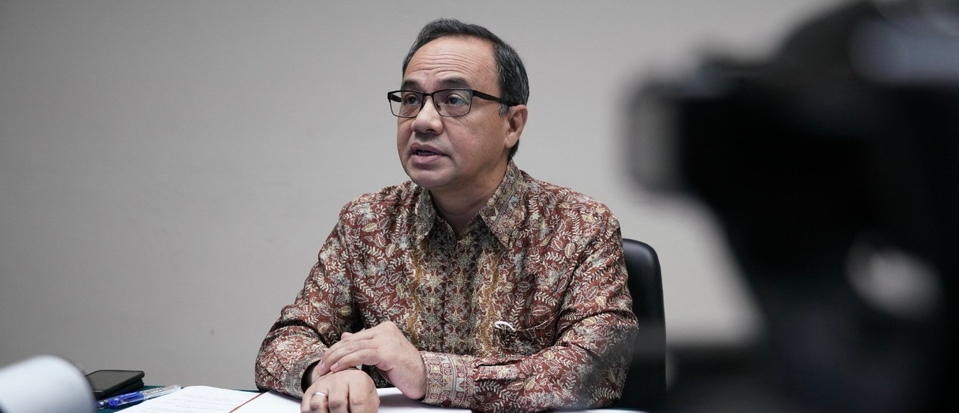

Ministry of Foreign Affairs Spokesperson/Director General of Public Information and Diplomacy, Teuku Faizasyah. The issue of strengthening ASEAN's institutional capacity and effectiveness was one of the focuses of the Minister of Foreign Affairs' discussion during the first quarterly briefing of the ASEAN Chairmanship in early April 2023. (Photo: Ministry of Foreign Affairs)

